

**Mid Term Project Report**

**Submitted By:**

**Kashir Saeed, 2020-CS-27 & Umair Ahmed, 2020-CS-3**

**Submitted To:**

**Sir Samyan Qayyum Wahla**

**For Fulfillment of**

**CS 261 Data Structure and Algorithm**

**Department of Computer Science**

**University of Engineering and Technology, Lahore**

**Data**

**Description:**

The data which we have scraped is the data of all the universities of the world. The data of universities has various attributes. Our data contains only those universities that are registered currently on world rank.

**Attributes of data:**

Our data of universities has the following attributes:

* Name
* Acronym
* Address
* Founded
* Motto
* World Rank
* Country Rank
* Telephone number
* Fax

**Name:**

This attribute contains the names of all the universities of the world. Its data type is string. These names are of those universities which are registered on world rank.

**Acronym:**

This attribute contains acronym of all the universities. Basically acronym is the short form of the name of university or we can say that its an abbreviation of the name of the universities .

**Address:**

This attribute contains the address of all the universities. On which address these universities are located, this type of information is provided in this attribute.

**Founded:**

In this attribute, the year in which this university was formed is mentioned. It is an integer type of data which contains the value year in which the particular university was formed .

**Motto:**

This attribute contains the string type of data which contains the motto of all the universities. Basically in our case, the motto of the university means the phrase which is suitable or appropiate for the university.

**World Rank:**

This attribute contains the integer type of data. Basically this attribute contains the rank of a university among all the universities of the world.

**Country Rank:**

This attribute is also an integer type of data. This attribute contains the ranks of the countries in which the particular university exists.

**Telephone Number:**

This attribute also contains string type of data. This attribute contains the contact numbers of all the universities of the world i.e: through this number we can contact with that particular university.

**Fax:**

This attribute is a string type of data. This attribute can also be used in order to contact with any university through its fax. It is a way of communication between public and university staff.

**Reference:**

These are the references or the links of websites from where we have tried to scrap the data:

* [**https://www.topuniversities.com/student-info/choosing-university/worlds-top-100-universities**](https://www.topuniversities.com/student-info/choosing-university/worlds-top-100-universities)
* [**https://www.topuniversities.com/university-rankings/world-university-rankings/2022**](https://www.topuniversities.com/university-rankings/world-university-rankings/2022)
* [**https://cwur.org/2020-21.php**](https://cwur.org/2020-21.php)
* [**https://www.4icu.org/top-universities-world/**](https://www.4icu.org/top-universities-world/)

**Problems:**

Initially these were the links from where we have tried to scrap the data. But we were facing various problem.

* After sometime we found that we were scraping same data from various wedsites.
* The data which we had scraped was not in a good condition
* Our data contains many trash values in it.

**Solution:**

After facing such problems we found a link. Through thar link, we scrapped the data te data of all the universities of the world. The data which we had scrapped is the data of those universities which are registered currently on world ranking. Initially our data contains many trash values but as a solution for this problem we cleaned that data. Or in other words, we removed the rubish data and stored only that data which was suitable for us.

**Visualization of scraping:**

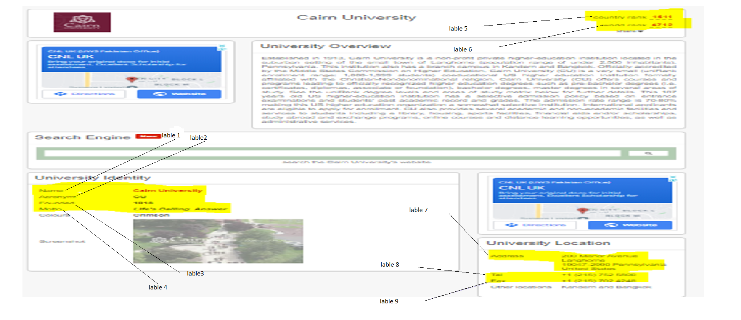

**Fig ( 1 )**

In the fig( 1 ),

* lable 1 🡪 name
* lable 2 🡪 acronym
* lable 3 🡪founded
* lable 4 🡪 motto
* lable 5 🡪 country rank
* lable 6 🡪 world rank
* lable 7 🡪 address
* lable 8 🡪 telephone number
* lable 9 🡪 fax

**Algorithms**

# Insertion Sort

## Defination:

In the insertion sort we select one element and suppose that the array at the left of the selected element is sorted and then we insert the selected element in the sorted array that is on the left side according to the sorted array. In this sort we compare the selected element to the previous at check if it is less than the previous the move one more to the left so on at the position where selected element become large and place the element at that point.

## Pseudo Code:

Key

for i=2 to n:

key=array[i]

index=i-1

while key<array[index] and index>=0:

array[index+1]=array[index]

index--

array[index+1]=key

## Code:

def InsertionSort(a):

    for i in range(1,len(a)):

        key=a[i]

        j=i-1

        while j>=0 and key<a[j]:

            a[j+1]=a[j]

            j-=1

        a[j+1]=key

## Time Complexity:

This algorithm takes O(n2)

## Strong Points:

1. If the array is already sorted than this algorithm takes O(n) times.
2. This sorting is stable.
3. If we have small input than this sorting algorithm is most efficient.

## Weak Points:

1. For the average case this sorting algorithm takes O(n2).
2. If we have the input in the reverse sorted order than this sorting algorithm takes maximum time because the inner loop execute to the zero index every time.
3. This sorting algorithm is not so efficient for the large number of input.

# Merge Sort

## Defination:

In the Merge Sort we divide the array in to two half arrays and continue so on until we reach the base case and then we start to merge these array in the sorted order by comparing each element of the partitioned array and we consider that these partitioned array are in the sorted order.

## Pseudo Code:

Merge(p,q,r,array)

n1=q-p+1

n2=r-q

left=[size n1]

right=[size n2]

for i =1 to n1:

left[i]=array[p-1+i]

for i =1 to n2:

right[i]=array[q+i]

k=p

i=0

j=0

while i<n1 and j<n2:

if left[i]<right[j]:

array[k]=left[i]

i++

k++

else:

array[k]=right[j]

j++

k++

while i<n1:

array[k]=left[i]

i++

k++

while i<n1:

array[k]=right[j]

j++

k++

MergeSort(p,r,array)

if p<r:

q=p+r/2

MergeSort(p,q-1,array)

MergeSort(q,r,array)

Merge(p,q,r,array)

## Code:

a=[9,2,4,3]

def Merge(start,m,end,array):

    n1=m-start+1

    n2=end-m

    l=[None]*(n1)

    r=[None]*(n2)

    for i in range(0,n1):

        l[i]=array[start+i]

    for i in range(0,n2):

        r[i]=array[m+1+i]

    i=0

    j=0

    k=start

    while i<n1 and j<n2:

        if(l[i]>r[j]):

            array[k]=r[j]

            j+=1

            k+=1

        else:

            array[k]=l[i]

            i+=1

            k+=1

    while i<n1:

        array[k]=l[i]

        i+=1

        k+=1

    while j<n2:

        array[k]=r[j]

        j+=1

        k+=1

def MergeSort(startInd,endInd,array):

    if(startInd<endInd):

        m=((endInd-1)+startInd)//2

        MergeSort(startInd, m, array)

        MergeSort(m+1, endInd, array)

        Merge(startInd,m,endInd,array)

MergeSort(0, len(a)-1, a)

print(a)

## Time Complexity:

Time complexity for this algorithm is O(nlgn).

## Strong Points:

1. This algorithm takes nlgn time that is much better than the n2 and this is also stable.
2. This sorting algorithm always takes same amount of time its time does not depend on the input.
3. This sorting algorithm goes through the array only one time.

## Weak Points:

1. If the give array is already in the sorted order than this algorithm also perform the complete execution on the array.
2. In this algorithm we first divide the array into two parts this takes some extra memory.
3. If our input is small than this algorithm does not perform well.

# Counting Sort

## Defination:

In the counting sort first we find the largest element of the array and then we make another array of size that is equal to the largest element. Then using for loop we access the each entry of the given array and at that position in the second we increment 1. After doing this we start loop from the index 2 on the second array and add each previous entry to its next one. Then we make an new array of size one that contain the sorted element. We apply the backword loop on the given array and access each value and then we access the value index of the second array and pick the value of the second array and one decrement the value of the picking position. After this we access the picked value index of the output array and place the value of the given array at that position in the output array when we repeat this procedure this will sort our given input.

## Pseudo Code:

Counting Sort(array,large,length)

c[0]*size large

b[size length]

for i=1 to length:

c[array[i]]++

for i=2 to large:

c[i]=c[i]+c[i-1]

for i=length to 1 downword:

b[c[array[i]]]=array[i]

c[array[i]]--

## Code:

array=[2,5,3,0,2,100000,0,3]

def CountingSort(array):

    large=-1

    b=[0]*len(array)

    for i in range(0,len(array)):

        if(large<array[i]):

            large=array[i]

    c=[0]*(large+1)

    for i in array:

        c[i]+=1

    for i in range(1,len(c)):

        c[i]+=c[i-1]

    for i in range(len(array)-1,-1,-1):

       b[c[array[i]]-1]=array[i]

       c[array[i]]=c[array[i]]-1

    return(b)

print(CountingSort(array))

## Time Complexity:

Time complexity for this algorithm is O(n)

## Strong Points:

1. Counting sort is stable.
2. This algorithm takes O(n) time this show that the algorithm is most efficient.
3. This algorithm sort the given input without comparison between numbers.

## Weak Points:

1. For the sorting of negative numbers this algorithm takes extra executions to scale and rescale the input.
2. If the largest of the input is too large number than this algorithm makes new array of that size which uses a lot of memory this is also a weak point.
3. If the input is in the form of string than this algorithm does not perform well.

# Radix Sort

## Defination:

In the radix sort we sort the given data on the bases of the radix. In the radix sort we will also use some linear sorting algorithm. First of all we sort the column of 1’s position using stable and linear sort than 10’s position and so on.

## Pseudo Code:

d=number of digits of the largest number

for i=1 to d:

Use linear sort to sort data according to the ith digit

## Code:

array=[329,457,657,839,436,720,255]

def RadixSort(array):

    def CountingSort(array,k,large):

        b=[0]*len(array)

        c=[0]*(large+1)

        for i in array:

            c[(i//k)%10]+=1

        for i in range(1,len(c)):

            c[i]+=c[i-1]

        for i in range(len(array)-1,-1,-1):

           b[c[((array[i]//k)%10)]-1]=array[i]

           c[(array[i]//k)%10]=c[(array[i]//k)%10]-1

        return(b)

    temp=1

    large=-1

    for i in range(0,len(array)):

        if(large<int(array[i])):

            large=int(array[i])

    for i in range(0,len(str(large))):

        array=CountingSort(array,temp,large)

        temp*=10

    return array

print(RadixSort(array))

## Time Complexity:

Time complexity for this algorithm is O(n).

## Strong Points:

1. The time taken by this algorithm is O(n).
2. This algorithm does not make array of large size as in the counting sort.
3. Radix sort is stable

## Weak Points:

1. If the input is negative numbers then this algorithm also takes extra executions to scale and rescale the input
2. This sorting algorithm is not much efficient for the sorting of the strings.
3. This sorting algorithm takes more memory than other sorts.

# Shell Sort

## Defination:

In the shell sort we first calculate the gap by dividing the length by 2. Then we compare each element with the element that is at the gap distance from the first one and if first element is greater than the other than replace it with the second one. And we repeat this procedure until the gap is equal to 1.

## Pseudo Code:

calculate gap

while gap>0:

for i=gap to n:

j=i

temp=array[i]

while j>=o and array[j-gap]>temp

array[j]=array[j-gap]

j-=gap

array[j]=temp

calculate gap

## Code:

array=[5,9,3,1,7,4,6,-8]

def ShellSort(array):

gap=len(array)//2

while gap>=1:

for j in range(gap,len(array)):

temp=array[j]

i=j

while (i>=gap and array[i-gap]>temp):

array[i]=array[i-gap]

i=i-gap

array[i]=temp

gap=gap//2

return array

print(ShellSort(array))

## Time Complexity:

Time complexity of this algorithm is O(n3) for worst case.

## Strong Points:

1. If the the given input is in the form that the elements with a minimum difference are far apart than this sorting algorithm performs well.

## Weak Points:

1. This sort is not so stable.
2. This sorting algorithm is a little bit difficult to understand
3. If the give input is so large than this algorithm does not perform well.

Bubble Sort

Definition:

In bubble sort, we compare the two consective elements of an array again and again. If the first element is greater than the other element than simply we swap the two elements. In this way after first iteration, the largest element of the array moves at the last position of the array. Similarly after second iteration the second largest element moves at the second last position and so own.

Pseudo Code:

bubbleSort( array )

for j = 1 to n

for k = 1 to n-j

if( array[ k ] > array[ k+1 ] )

swap both

return array

Python Code:

array = [10,3,13,8,15,4,0,15]

for i in range(len(array)):

for j in range(1,len(array)-i ):

index = j-1

if(array[index] > array[j] ):

temp = array[j]

array[j] = array[index]

array[index] = temp

print("Sorted array is: ")

print(array)

Time complexity:

This sorting algorithm takes O(n2 ) time.

Strong points:

* Its code is simple because it consists of comparison of two numbers and swaping them.
* Inner loop of bubble sort does not executes exactly n times
* It is a stable sorting algorithm.

Weak points:

* In this algorithm, comparison between the elements is done for sorting
* It is not efficient because it takes O(n2) time for sorting
* If the array is already sorted than it still takes O(n2) time

Selection Sort

Definition:

In case of selection sort, this algorithm first finds smallest element of the array. After finding smallest element of the array, it places that element at the 0 index of the array. Again the smallest element is found from the rest of the array and it is placed at the second index and this process is repeated several times until the array ends.

Pseudo Code:

SelectionSort( array )

For j =1 to array.len

Key = array[i]

For k = i+1 to array.len

If( key > array[k] )

Swap both

Python Code:

array = [6,2,8,3,4]

for i in range(len(array)):

key = array[i]

for j in range( i+1, len(array)):

if(key > array[j] ):

temp = array[j]

array[j] = key

array[i] = temp

key = array[i]

print("Sorted array is: ")

print(array)

Time complexity:

This sorting algorithm takes O(n2 ) time.

Strong points:

* This sorting algorithm requires only sufficient space. I have used only two extra variables in this algorithm
* Its logic is very simple because we just have to find the smallest element and insert at the starting of the array.
* This sorting algorithm works efficiently for the small number of elements.

Weak points:

* In this algorithm, comparison between the elements is done for sorting which is its drawback
* This sorting algorithm is unstable.
* If the array is already sorted than it still takes O(n2) time.

Bucket Sort

Definition:

In bucket sort, firstly the input should be in the range of [ 0 , 1). Whatever the user gives the input firstly we have to convert it in this range. After that we multiply each element of the array with the total length of the array, taking floor of each element and putting each element of the array into the buckets according to the answers after taking floor. Then we apply insertion sort on each bucket and concatenate them.

Pseudo Code:

Let res[ 0 … n-1 ] ------> a new array

n = array.length

for I =1 to n-1

( making buckets in array res )

for j =1 to n-1

insert array[ j ] into res[ floor( n * array[ j ] ) ]

for k =1 to n-1

( sort each bucket by insertion sort )

Concatenate all the buckets ( res[0] , res[1] …. )

Python Code:

import math

given_array = [12,4,-4,5,-7]

array1 = []

smallest_element = given_array[0]

for i in range(1,len(given_array)):

if(smallest_element > given_array[i] ):

smallest_element = given_array[i]

for i in range(len(given_array)):

if(smallest_element < 0 ):

given_array[i] = given_array[i] + (smallest_element * (-1))

else:

given_array[i] = given_array[i] + (smallest_element )

largest_number = given_array[0]

for i in range(len(given_array)):

if(largest_number < given_array[i] ):

largest_number = given_array[i]

largest_length = len(str(largest_number))

for i in range(len(given_array)):

if(given_array[i] >= 1 ):

array1.append((given_array[i] / (10**largest_length) ))

if(given_array[i] >= 0 and given_array[i] < 1):

array1.append(given_array[i])

no_of_buckets = len(array1)-1

def bucket_Sort(array1):

n=len(array1)

buckets_list = []

for i in range(no_of_buckets+1):

buckets_list.append([])

for i in range(len(array1)):

buckets_list[math.floor(array1[i] * n)].append(array1[i])

for k in range(len(buckets_list)):

flag = 0

for i in range(1 , len(buckets_list[k])) :

j = i-1

key = buckets_list[k][i]

flag = 0

while(j >= 0 and ((key < buckets_list[k][j])) ):

buckets_list[k][j+1] = buckets_list[k][j]

j = j-1

flag = 1

if(flag == 1):

buckets_list[k][j+1] = key

array1 = []

for k in range(len(buckets_list)):

array1 = array1 + buckets_list[k]

for i in range(len(array1)):

length = len(str(array1[i]))

array1[i]=int(((array1[i] * (10**largest_length))))

for i in range(len(array1)):

if(smallest_element < 0 ):

array1[i] = array1[i] - (smallest_element * (-1))

else:

array1[i] = array1[i] - (smallest_element )

return array1

print( "sorted array is:--- " + str(bucket_Sort(array1)))

Time complexity:

This sorting algorithm takes O(n2 ) time.

Strong points:

* Bucket sort is a stable sorting algorithm.
* Its best base time complexity is O(n+k).
* This sorting algorithm sorts the given array without any comparisons.

Weak points:

* This sorting algorithm has a worst case time complexity oof O( n2 ).
* This sorting algorithm is applicable for the inputs ranging from {0 , 1).
* If the inputs are negative numbers, then some extra time execution is required for scaling the given array.

Quick Sort

Definition:

In quick sort, we select a pivot and arrange the array in such a way that smaller elements should be on the right side of the array and larger elements on the left side. The pivot goes to its original position. This process is repeated again and again until all the elements goes to their original position.

Pseudo Code:

quicksort( A , p , r )

if ( p < r )

q = partition (array , p , r)

quicksort( array , p , q-1 )

quicksort( array, q+1 , r )

partition(array , p , r)

x = array[r]

I = p-1

For j = p to r-1

If( array[j] <= x )

I+=1

Swap array[i] and array[j]

Swap array[i+1] with array[r]

Retrn i+1

Python Code:

array = [4,1,3,9,7]

def quick_sort(array , low, high):

if(low < high):

pivot_index = partition(array , low , high)

quick_sort(array , low , pivot_index-1)

quick_sort(array , pivot_index+1 , high)

return array

def partition(array , low ,high):

pivot = array[high]

i = low-1

for j in range(low , high):

if(array[j] < pivot ):

i = i+1

temp1 = array[j]

array[j] = array[i]

array[i] = temp1

temp2 = array[i+1]

array[i+1] = array[high]

array[high] = temp2

return (i+1)

Time complexity:

This sorting algorithm takes O(nlog n) time.

Strong points:

* For small number of items , quick sort works better than merge sort.
* The time complexity of quick sort is better than bubble sort.
* In quick sort , divide and conquer approach is used rather than simple iteration method.

Weak points:

* This sorting algorithm is not a stable algorithm.
* This sorting algorithm is based on comparison between the elements of the array
* If the array is already sorted than it is the worst case of quick sort.

Selection Sort

Definition:

In comb sort, we divide the gap of the array with 1.3,as a result new gap is formed. We compare elements of the 0th index and the index gap index, 1st index and the (gap+1) , 2ns index and (gap+2) and so on.. we swap the smaller elements to the left side. When the addition in gap reaches length of the array then the previous gap is divided again. This process is repeated again and again

Pseudo Code:

Starter = array.length - 1

I = 0

J = starter

While (starter > 1)

If ( array[i] > array[j] )

temp=array[i]

array[i]=array[j]

array[j]=temp

if( j==len(array)-1 ):

starter= starter/1.3

j=starter

i=0

else:

i+=1

j+=1

Python Code:

array=[1,9,7,3,6,4,5,-8,-5,-2,-1]

starter=int(len(array)-1)

i=0

j=int(starter)

while starter>=1:

if(array[i]>array[j]):

temp=array[i]

array[i]=array[j]

array[j]=temp

if(j==len(array)-1):

starter=int(starter//1.3)

j=starter

i=0

else:

i+=1

j+=1

print(array)

Time complexity:

This sorting algorithm takes O(n2) time.

Strong points:

* Comb sort is a stable sorting algorithm.
* Comb sort is very efficient than bubble sort
* Its best case time complexity is O(n logn)

Weak points:

* This sorting algorithm performs sorting by comparing elements of the array
* Its worst case time complexity is O(n2)
* This sorting algorithm is also slower than shell sort.

Flash Sort

Definition:

In this sorting algorithm, first we find smallest element of the array and place it on the first index. Then we find smallest element from the rest of the array and place it at the second position and this process is repeated again and again.

Pseudo Code:

For i=1 to array.len

Small = array[i]

For j = I to array.len

If( small > array[j] )

Small = array[ j ]

Index = j

temp = array[i]

array[i] = small

array[temp_index] = temp

Python Code:

def flash_Sort(array):

#small = array[0]

for i in range(len(array)):

small = array[i]

temp_index = i

for j in range(i,len(array)):

if(small > array[j]):

#print(small)

small = array[j]

temp_index = j

temp = array[i]

#print(temp_index)

array[i] = small

array[temp_index] = temp

print(array)

Time complexity:

This sorting algorithm takes O(n2) time.

Strong points:

* Best case of flash sort is O(n)
* This sorting algorithm is much faster than heap sort
* If the number of elements are greater than it is better than quick sort.

Weak points:

* Worst case of flash sort is O(n2)
* In this algorithm, sorting is done by comparing the elements of the array.
* This sorting algorithm is not stable

# Dry Run

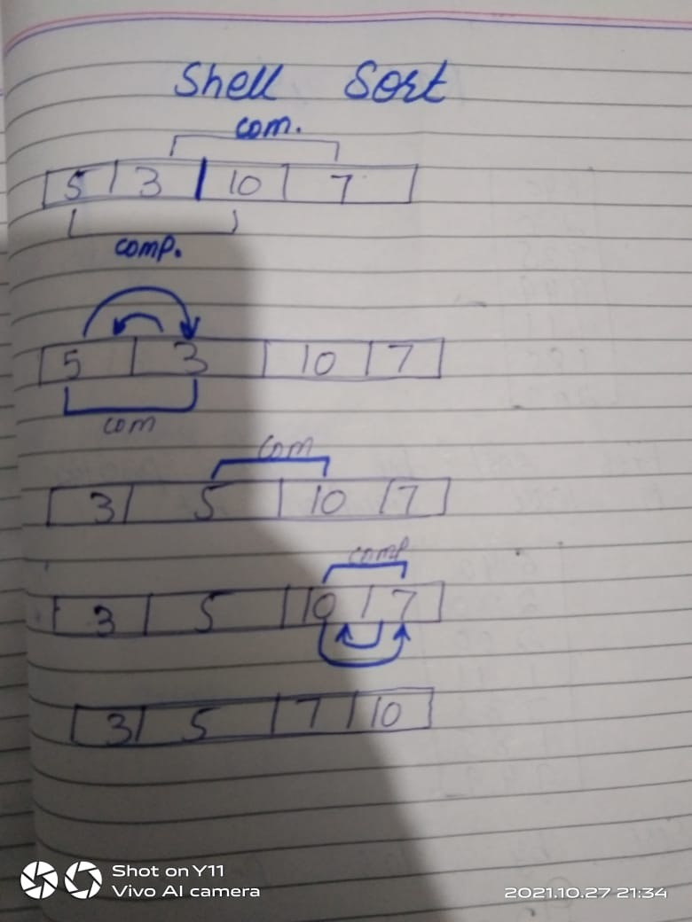

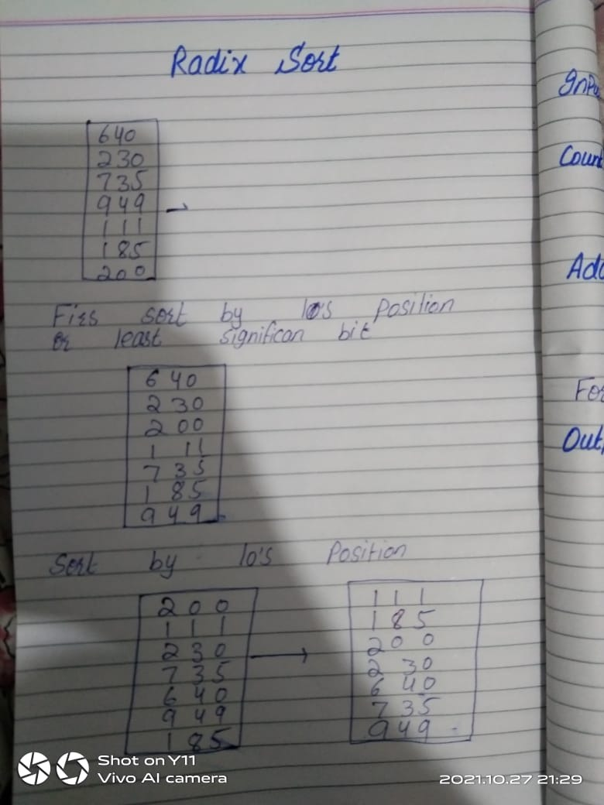

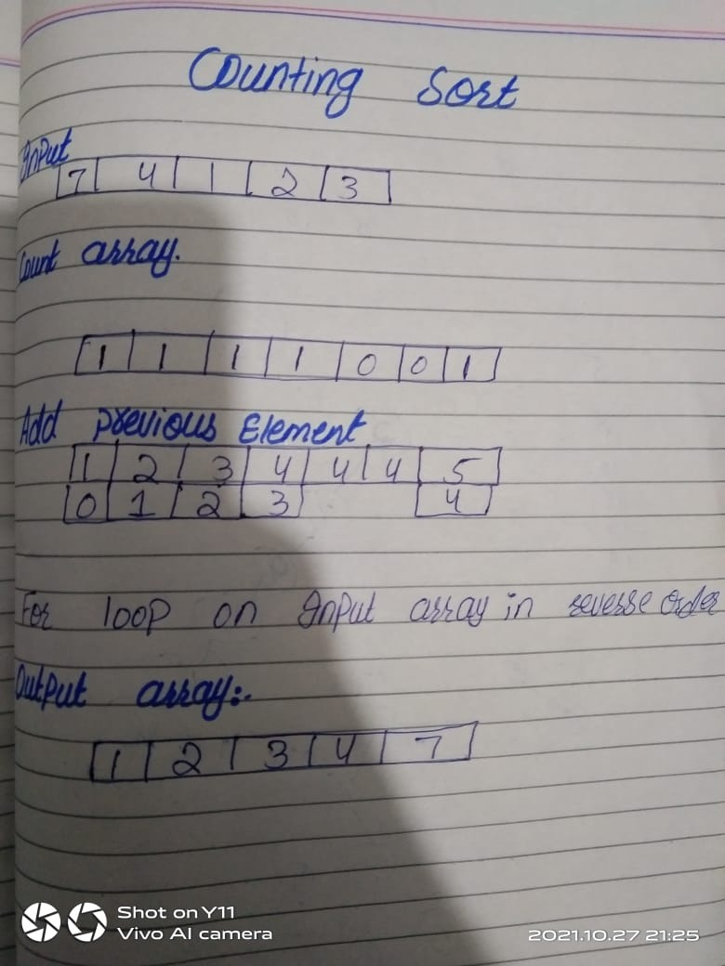

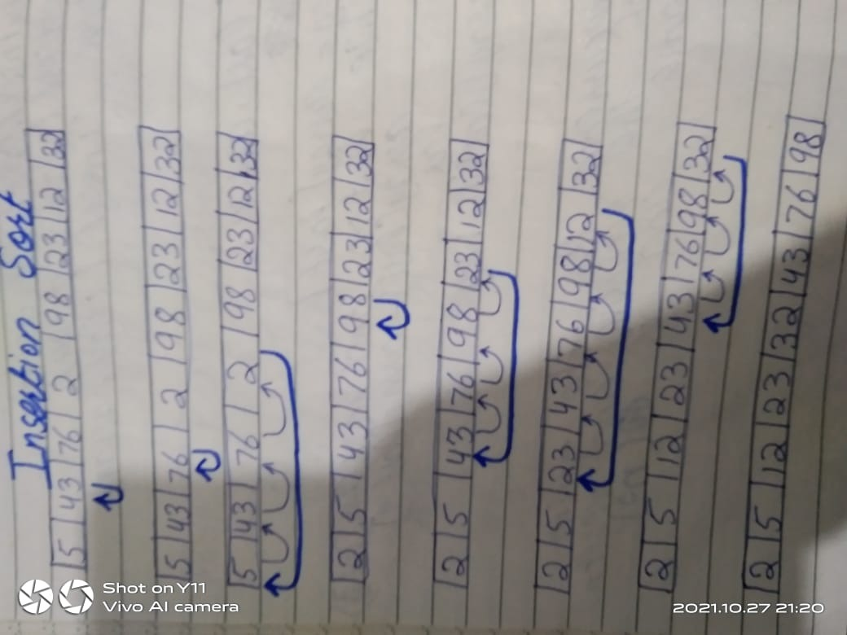

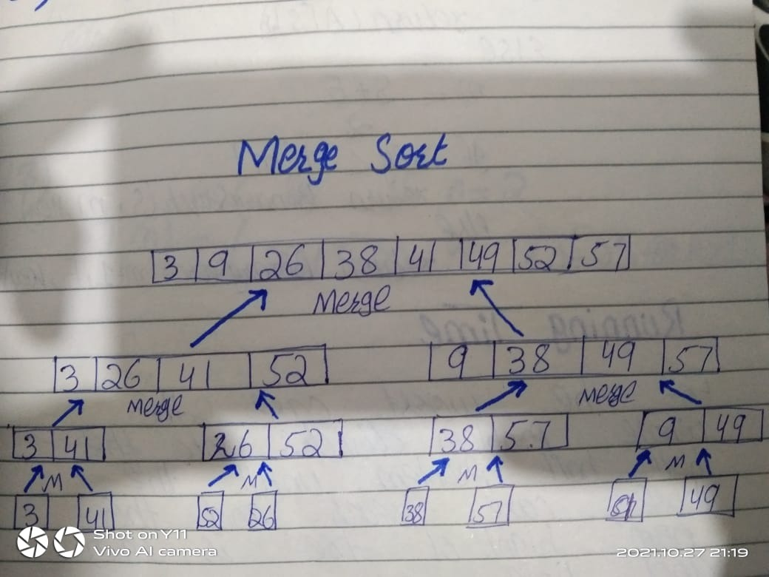

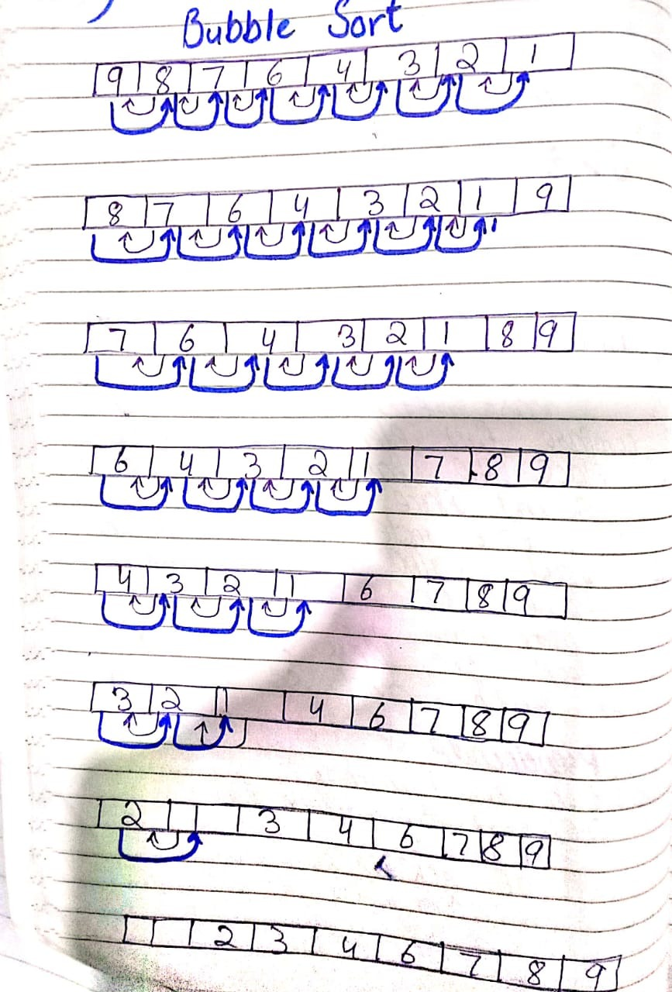

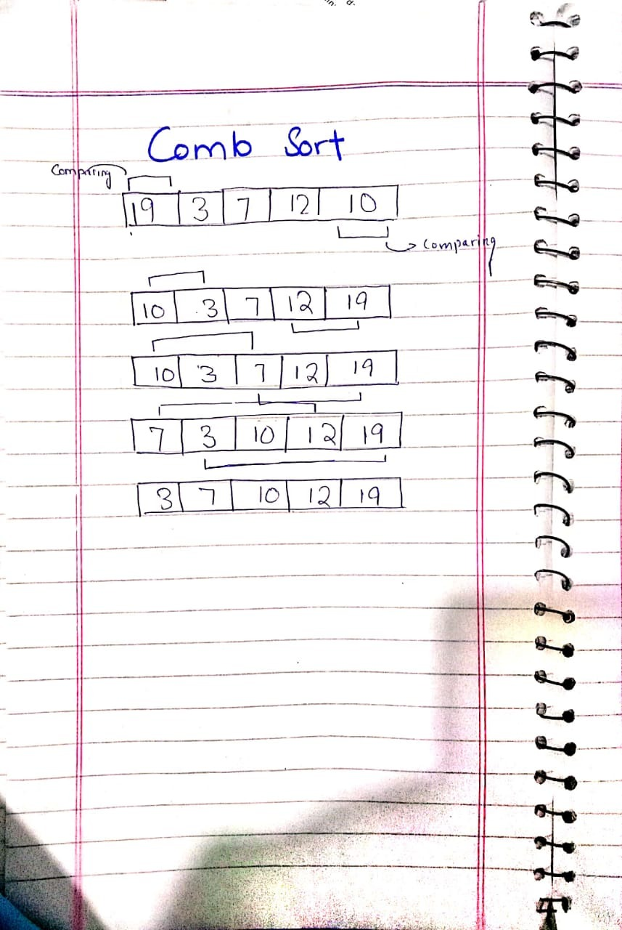

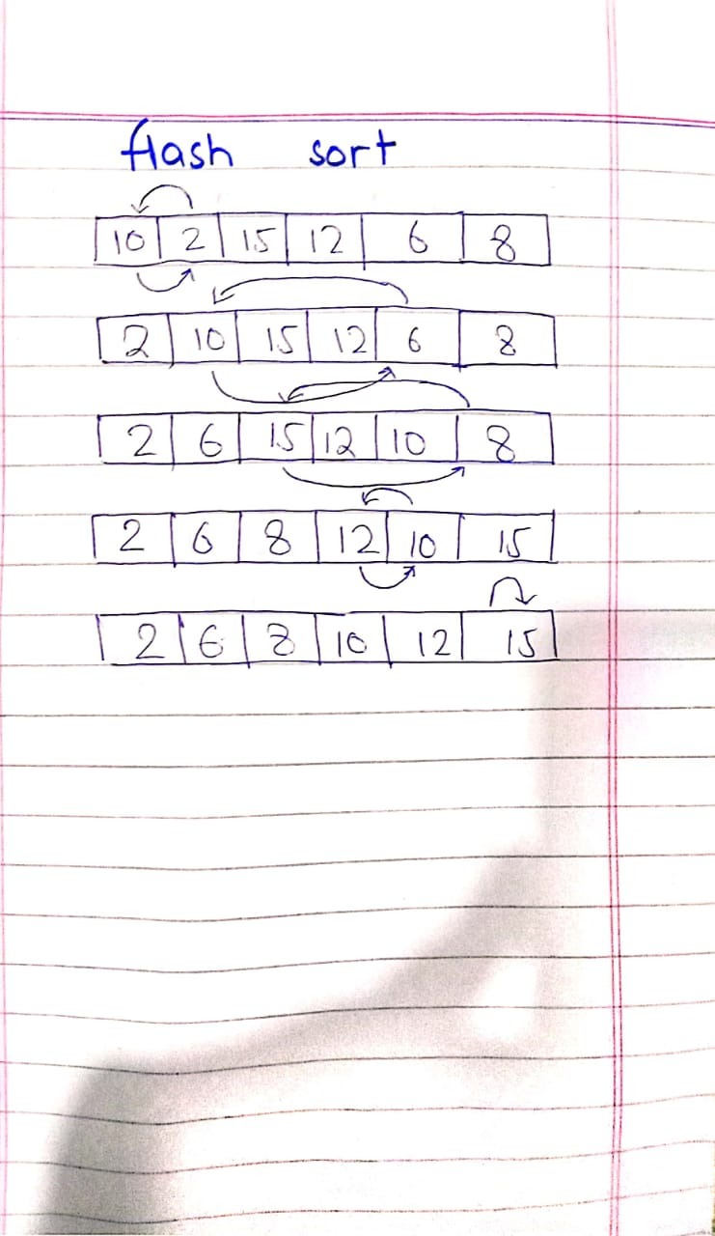

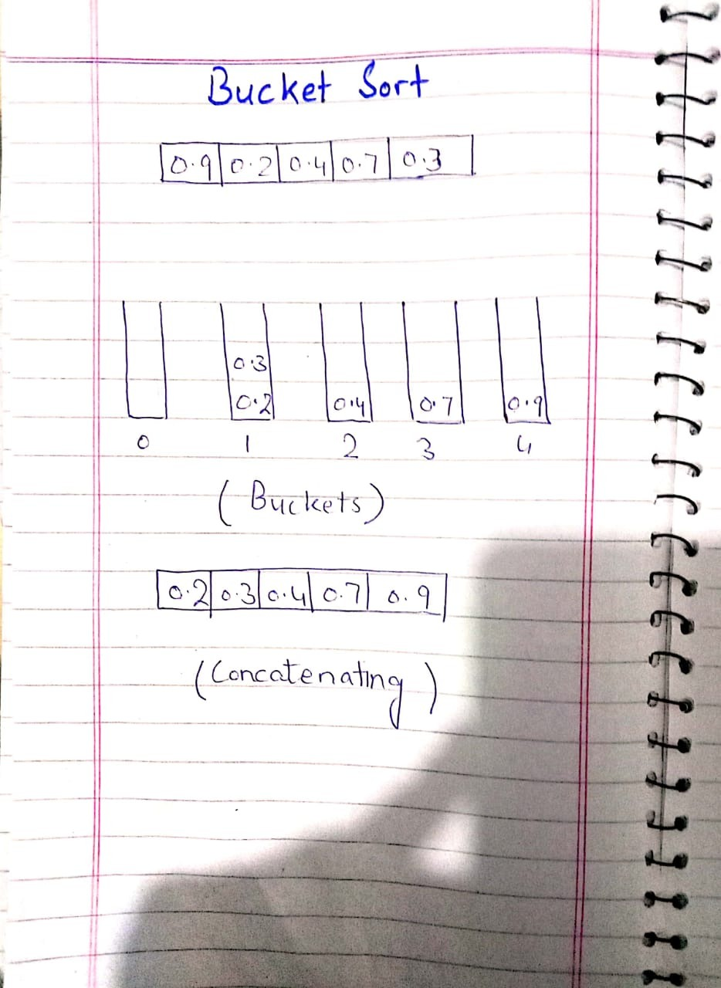

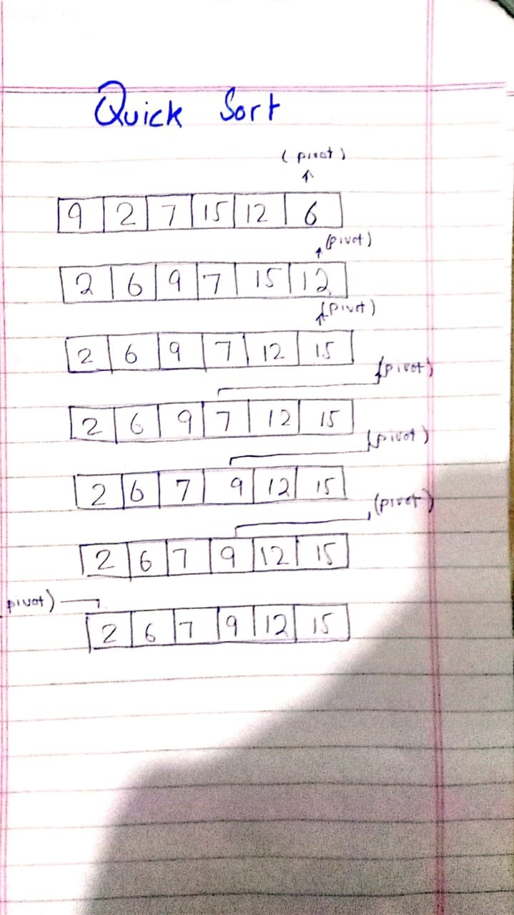

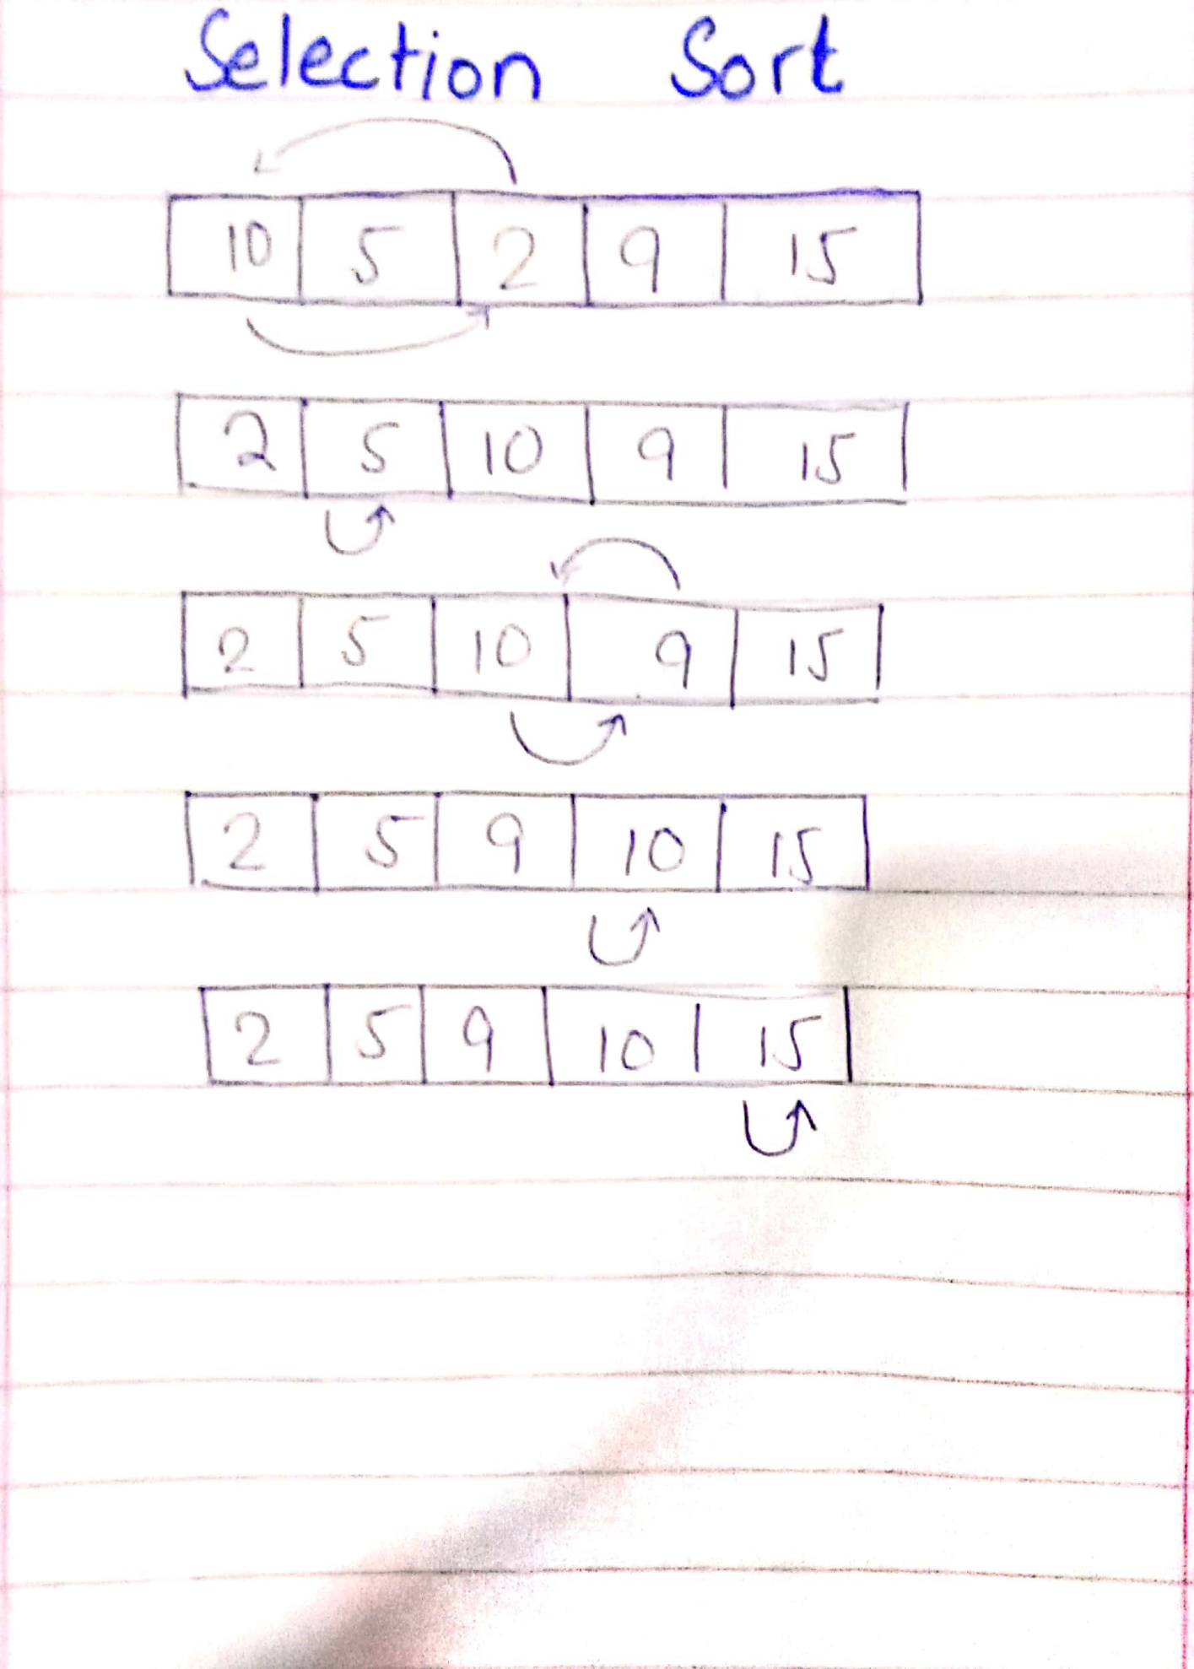

# Time Analysis

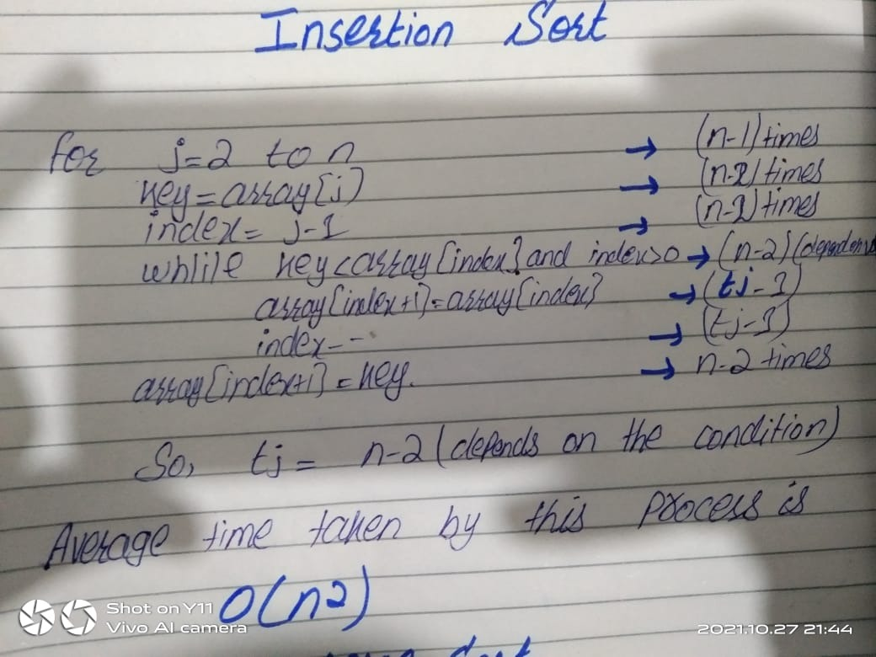

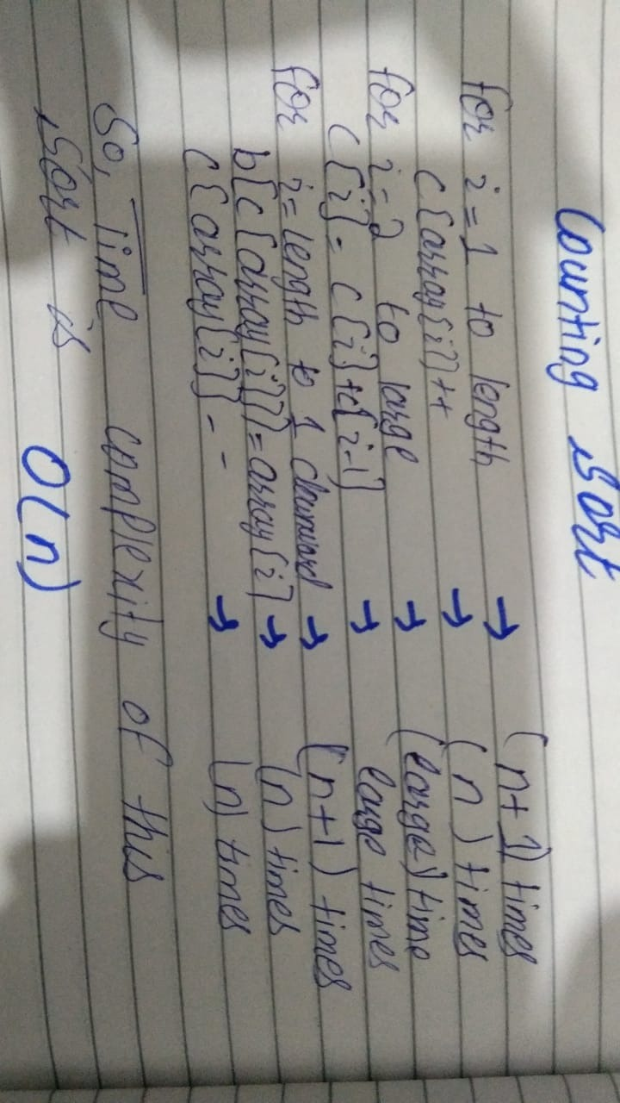

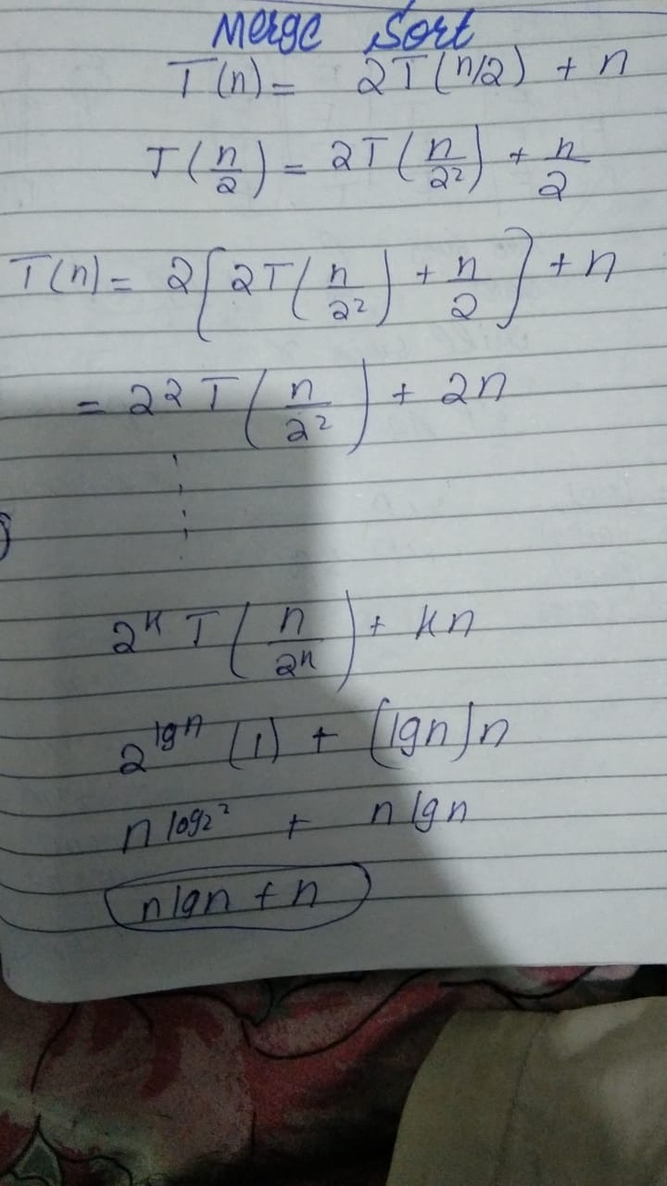

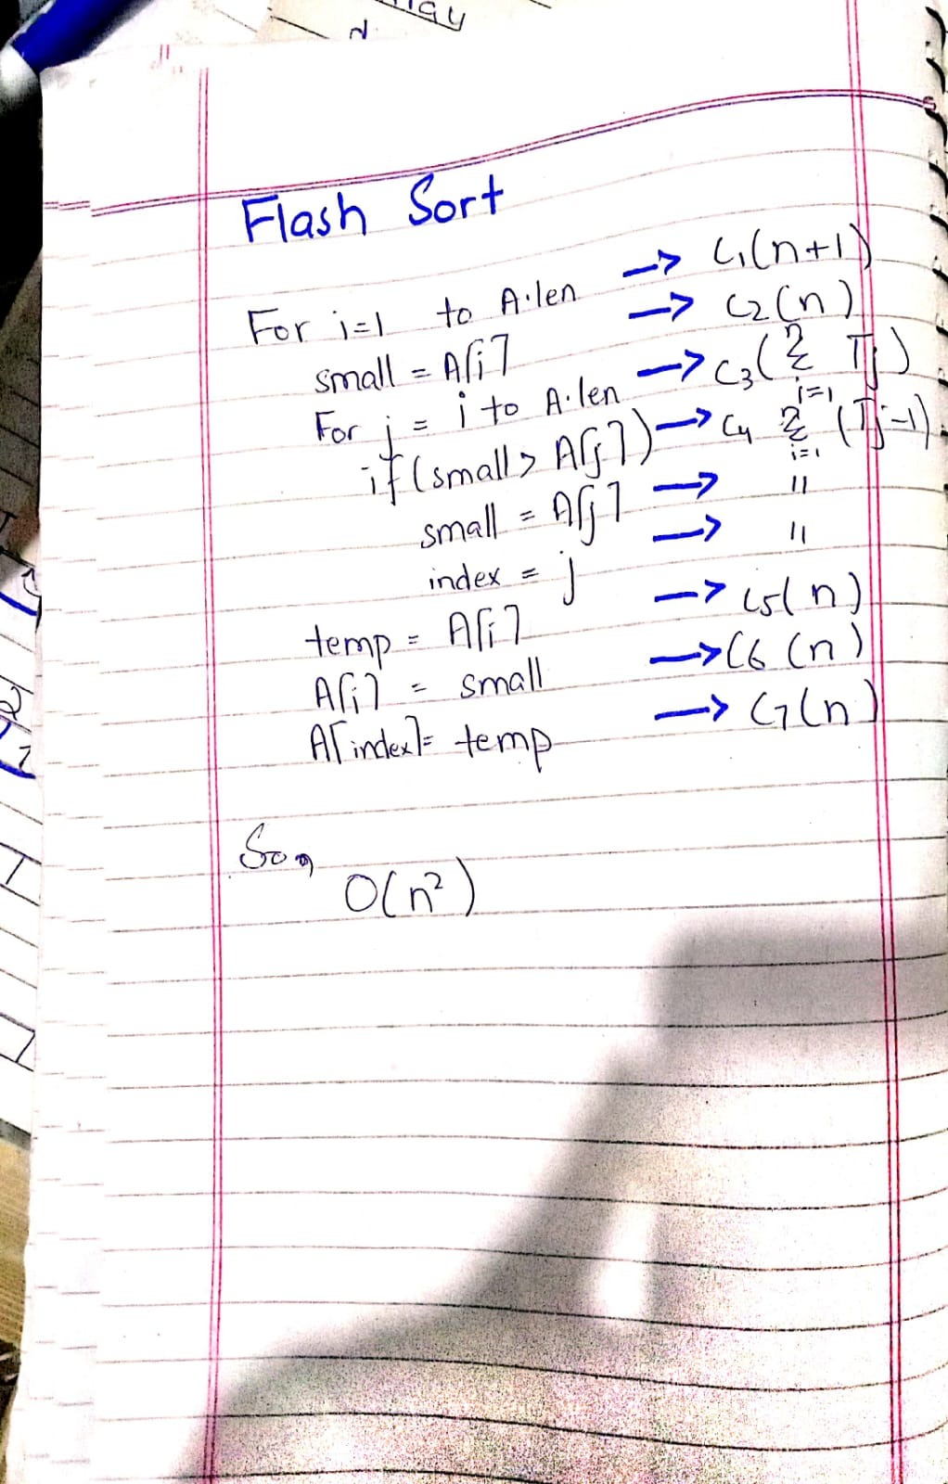

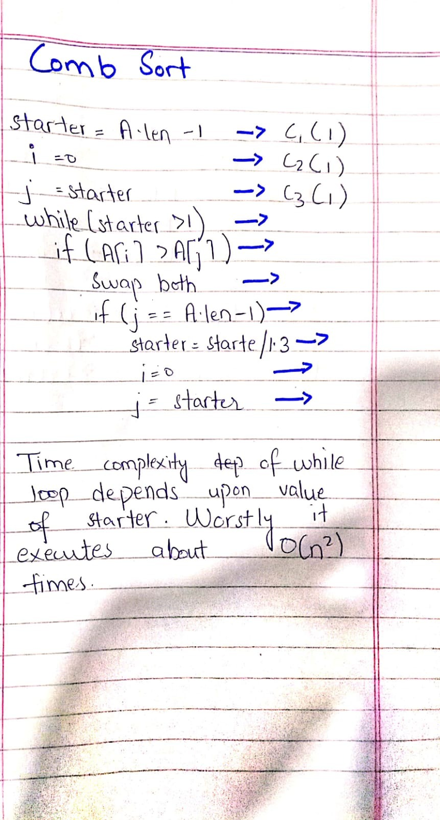

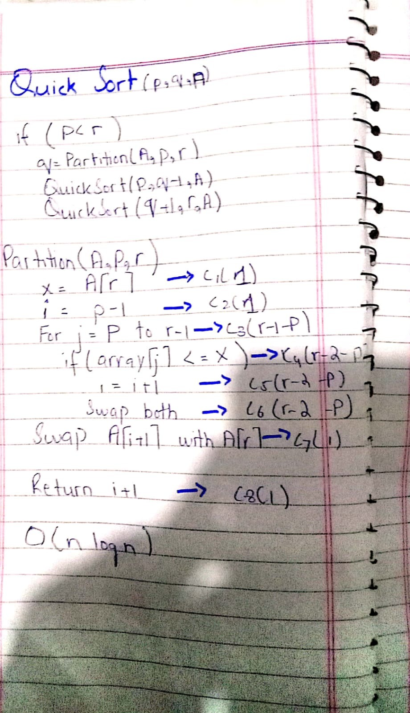

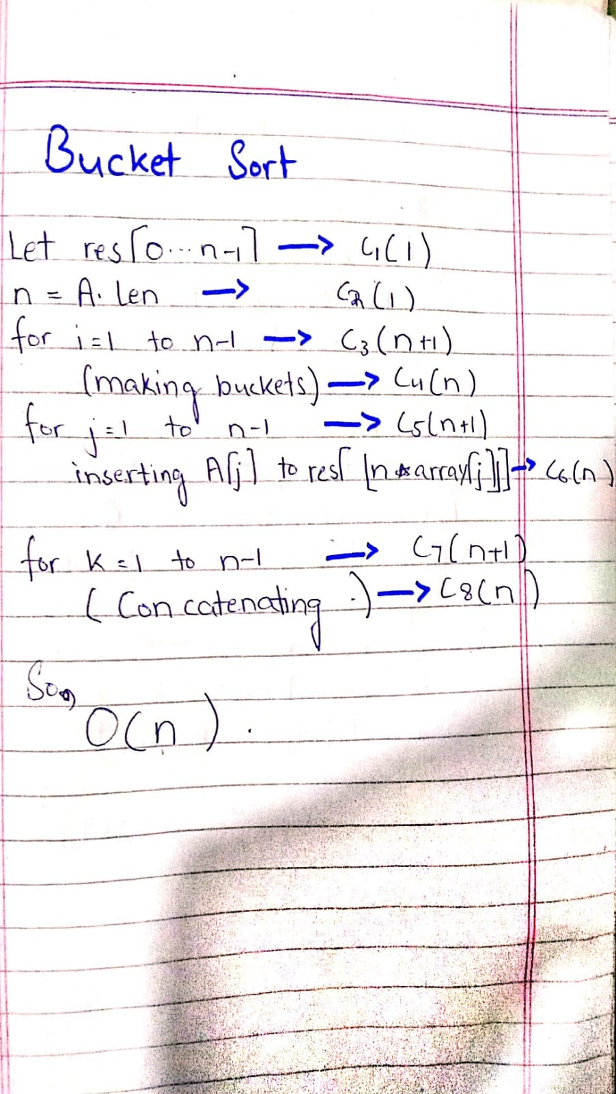

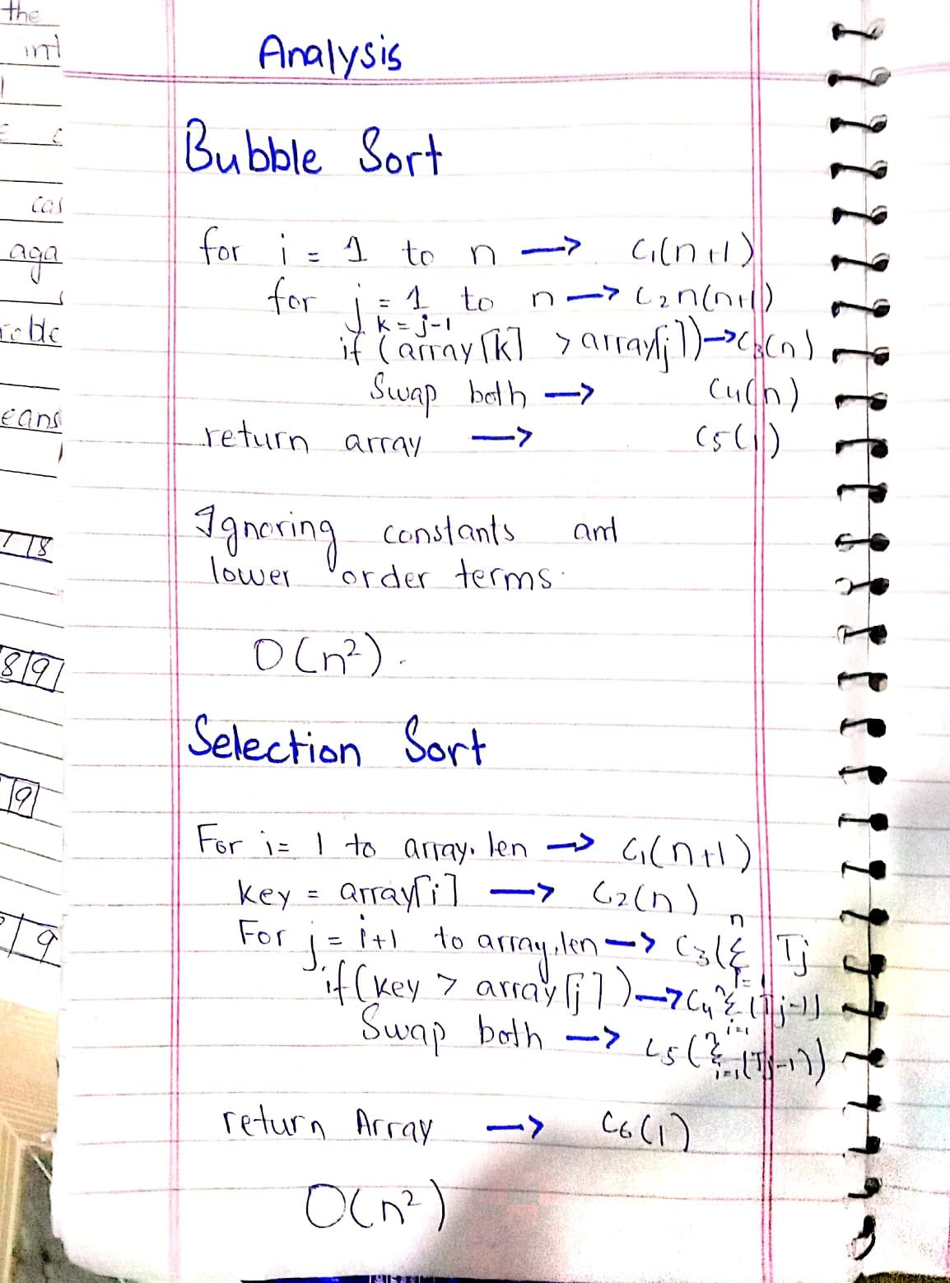

**Searching Algorithms**

There are two types of searches in our project:

* Linear Search
* Binary Search

**Linear Search:**

This linear search is searching algorithm. Linear means that we will check each element of the given array step by step. As usual, search means the finding of element from a given array

So, linear search is an algorithm in which we compared the key with each element of the array. When the key matches with the any element of the array, so our element in the array is found. As a result, linear search is performed.

**Strong points:**

* Our given array is no need to be sorted
* If insertion and deletion is applied than it does not effect it.
* Its performance is good for small number of data.

**Weak points:**

* It is not efficient for large number of data.
* Its time complexity is much more than that of binary search.
* In the worst case, every element of the array is accessed which is not good.

**Problems:**

We haven’t face any type of problem in linear search.

**Binary Search:**

This binary search is also a searching algorithm. Binary means “two” it means that an should be divided into two parts. As usual, search means finding an element from array. So, in binary search, first we divide the given array into two parts. Than we compare our key with the middle index value. If our key is less than yhe middle element than we move towards first half of the array otherwise we move towards the second half of the array. This process is repeated agai n and again till reaching the required index. In binary search, the given array should be sorted.

**Strong points:**

* It is much quicker than linear search.
* Its time complexity is lg n because it divides the array into two parts again and again.
* It works efficiently even for large number of data as compared to linear search.

**Weak points:**

* Its one big disadvantage is that the given array should be sorted
* As we know that in this algorithm recursive approach is used so more amount of stack is required.
* Its not very easy to understand and its code is very difficult to handle.

**Problems:**

In binary search, firstly our code was working properly for integers only. It gives us the correct value while using integers. But as we passed string to the function instead of integer, our code started creating problems for us. It was not working properly for strings because our scrapped data contains some unknown characters in it. As we know that binary search works only when the given array is sorted, error was also generating because initially we were passing unsorted array to the function.

**Solution:**

As a solution for these problems, Firstly, we started passing the sorted array to the function of binary search. Other thing was that we removed all the unusual characters from our data and then performed the binary search. So, as a result, our binary search algorithms started working properly.

**UI ( user interface )**

**Wireframe:**

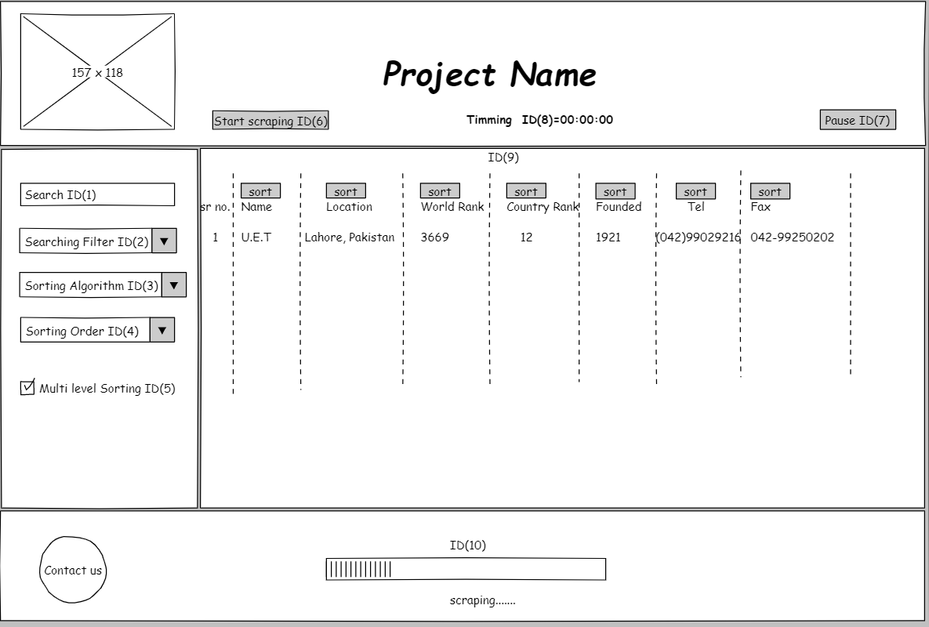

**Fig( 2 )**

|  |  |  |
| --- | --- | --- |
| UI Component Name | Type of UI component | Purpose of UI Component/Other details |
| ID(1) | Text Box | This is used to search items from the data. |
| ID(2) | Combo Box | This is used to select the search filter. |
| ID(3) | Combo Box | This is used select the sorting algorithm. |
| ID(4) | Combo Box | This is used to select the sorting order. |
| ID(5) | Check Box | This is used to enable the Multi Level Sorting |
| ID(6) | Button | This is used to start the scraping. |
| ID(7) | Button | This is used to pause the sorting. |
| ID(8) | Label | This will show the timing of the scraping. |
| ID(9) | Grid | This is used to show the data. |
| ID(10) | Progress Bar | This is used to show how much data is scrapped. |

**Working**

**Start scraping:**

It is a button on user interface. As the button of start scraping is pressed, a new chrome diver opens and the scraping of all the universities of the world starts. The only purpose of thisis button is to scrap the data.

**Pause:**

We can also pause the scraping of all the universities of the world. For this purpose, we have used a separate button. We can stop the scraping of our project at any time using this project.

**Time:**

Its component type is lable. The lable of time is used for many purposes. In order to show how much time our scraping takes, this time lable is used to show that time. It also shows how much time each of the sorting algorithm takes for sorting the data.

**Searching :**

In order to do search in our project, we have used a search panel. It is a type of text box. We can perform any type of search using this search using this search panel. There isn’t any restriction for searching any thing in our project.

**Sorting Algorithm:**

We this purpose, we have used a combo box. Its purpose is to display the list of all the sorting algorithms which we have use in our project. We can select any of the sorting algorithm using this combo box.

**Sorting Order:**

In order to display all the sorting orders, we have again used a combo box. This combo box displays all the sorting orders which we have used in our project and we can select any one of them.

**Progress Bar :**

We have used a progress bar in our project. Its purpose is to display how much scrapping of our data is done and is displayed at the bottom of our project windox.

**Multilevel sorting:**

In order to apply multilevel sorting, we have used a check box. In order to apply multilevel sorting, first of all we check our check box and then we apply sorting. tn this war, multilevel sorting is performed.

**Grid**:

Only one gird we have used in our project. All the data of our project is shown in this grid. The purpose of this grid is to show the data of all the universities of the world in row and column form.

**Attribute:**

Its component type is combo box. The purpose of this option is to display all the attributes of our data. We have to select any one of them in order to perform sorting. As a result, all the data of the universities is sorted according to the selected attribute.

**Searching Filters:**

We have used a combo box for this purpose. There are two types of searching filters. These are linear search and binary search. We have to select any one of them so as a result our search will be performed according to the selected filter.

**Improvements**

**Load Data:**

As an improvement, we have added a load data button. The purpose of this button is to load the data of all the universities of all the world. As the button is pressed, the data of all the universities is loaded from the CSV file and is displayed I the grid.

**Sort Button:**

We have also added a sort button as an improvement. Before pressing this button, first of all we selects the searching filter, name of sorting algorithm, sorting order and the attribute which we have to sort. After that we press this button. As a result, the data is sorted according to the information that we have given above.

**Collaboration**

**Stage 1:**

Our first task was to design a proposal for our project. We collaborated this task in such a way that half of the portion of the proposal was assigned to the one member and the nsxt half to the other one. After completing this, we were surprised to hear that the proposal of all the students was rejected and a new template of the proposal was uploaded on eduko. We did this in a similar manner as we have done it previously.

**Stage 2:**

Now, our next task was to make word file of the sorting algorithms. The requirement was that each sorting algorithm should have some description, pseudo code, python code. correctness, advantages and disadvantages. This task requires a lot of time. So, we collaborated in such a way that out of 12, algorithms 6 sorting algorithms, along with their all properties, were assigned to one member and the next 6 to the other. In tis way we completed this task.

**Stage 3:**

Step 3 was a UI implementation. First of all we watched some vedioes on youtube releted to **PYQT5.** We were very happy because we felt that it’s a very easy task. We were thinking that we just have to drag and drop the tools of **QT Designer** and our GUI would be ready. So, one of us did this quite easily. But after some days we came to know that during UI implementation, we also have to implement all the events ( for example: click event ) which were used in our project. At that time, we haven’t implemented even a single event on or project. This was a big mistake from our side.

**Stage 4:**

Then both of us made a github account and uploaded some of our UI implementation on github. Initially, we don’t know how to use github but one our friend guided us so much related to the work of github.

**Stage 5:**

Now, the next task was to scrap the data of all the universities of the world. As our previous task of implementing the events was left so, one of us had done scraping and the other one implemented the events in the project.

**Stage 6:**

Due to the shortage of time, one of us integrated all the sorted algorithms with the user interface and the other one made the report of the whole project. In this way, we collaborated our whole project.

**Integration**

**How each of the file is integrated with our project ???**

**Total files in project:**

There are total 13 files in our project. Out of which 8 are python files, 4 are CSV files and 1 is UI file. These files are as following:

* Algorithms.py
* Events.py
* GUI.py
* MultilevelSorting.py
* ScrapData.py
* ScrapLinks.py
* Search.py
* Sort.py
* GUI.ui
* Links.csv
* searchData.csv
* university.csv
* university2.csv

**Working**

**Algorithms.py:**

This file contains a parent class name as **Algorithms.** This parent class has 11 child classes which all are named according to their respective sorting algorithms. All these extends their parent class and all of them a have a common function. Whenever we press **Sort** button from our user interface, than one these functions is called .as a result sorting is performed.

**Events.py:**

Working of this file is very important. This file contains many functions. One of them is **loadData()** function. As the button of load data is pressed, then the data from the CSV file automatically loads into the grid of our UI. In this file, **searchData()** function finds all the elements from the CSV file which are searched in a search panel. **SortData()** function calls the function from the Algorithhms.py file and sorts the data.It also contains the function of pause(), start() and message(). Start function starts the scraping of our project, pause function stops the scrapping and the message function displays a message box with some text written on it.

**GUI.py and GUI.ui file:**

We have designed our GUI with the help of **Qt designer.** The QT designer provides us the facility of dragging and dropping the components of it. We did it in the same way. Because of dragging and dropping, some code was automatically generated in the GUI.ui file. We converted that file to GUI.py file ( python file ). This file contains the UI of our project.

**multilevelSorting.py file:**

This file contains a class of university and a function of **nultilevelSorting**(). As the user selects the option of multilevel sorting from our user interface, the function of multilevelSorting() from this file is called and as a result multilevel sorting is performed on the given data of universities.

**ScrapLinks.py file:**

This file only contains the code of scrapping. As the button of start scrap is pressed from our UI, then first of all the code of this file is executed. As a result, the links of all the websites from where we have to scrap the data are stored.

**scrapData.py file:**

This file contains the function of **startScrapping()** . As the button of start scraping is pressed, then this function scraps the data of all the universities from each link which we have stored before. As a result, the data of all the universities is scrapped.

**Search.py file:**

This file contains the code of linear search and binary search. Linear search finds the data linearly by comparing the key with each and every entity until the required entity if found. Where as binary search works a bit differently and finds the required data with a different approach.

**Sort.py file:**

Whenever the user selects one of the sorting algorithms from the combo box of user interface, the code of this file checks which file the user has selected from the UI. According to that select, the function of respective sorting algorithm is called from the Algoritms.py file.

**CSV files:**

Links.csv contains the links of all the websites from where we have to scrap the data. searchData.csv contains the data which has been searched from the searched from the search panel. University2.csv contains the data of all the universities of the world along with there attributes.

**Problems**

The problem that we faced while integration was that as the button of start scrapping was pressed, the browsing starts. We were unable to do anything in our project until the whole scraping ends. This problem was solved with the help of threading. We created a new function of threading, which resolves that issue.